Curriculum Vitae

CHANDRAKANT P. ZILPE

At Post: Allipur Ta: Hinganghat

Dist: Wardha – 442304

E -mail : chandrakantzilpe@gmail.com

Mob: 9021394487, 8208914602

OBJECTIVE :

I look forward to associate myself with a progressive and professional organization where there is growth and potential realization of person’s abilities and skills.

PERSONAL PROFILE :

Name : Chandrakant Prakashrao Zilpe

Father’s Name : Prakashrao Mahadeorao Zilpe

Local Address : C/O. Dr. Sheshrao Bawankar, Behind Yashwant D.Ed.

College, Kolhe Layout, Ram Nagar, Wardha.-442001

Date of Birth : June 26, 1979

Sex : Male

Nationality : Indian

Religion : Hindu

Marital Status : Married

Language Known : Marathi, Hindi, English

EDUCATIONAL QUALIFICATION :

NAME OF THE EXAM | BOARD/UNIVERSITY | YEAR OF PASSING | PERCENTAGE
SSC | Delhi (CBSE) | Mar 1995 | 44.20
HSSC | Nagpur | Mar 1997 | 61
B.A. | RTM Nagpur | Sum 2000 | 55.20
B.Ed. | RTM Nagpur | Sum 2005 | 77.70
M.Ed | RTM Nagpur | Sum 2012 | 59.67
M.A.(Eng.) | BAMU Aurangabad | Sum 2014 | 60.38
LL.B. | RTM Nagpur | Pursuing | -----------

COMPUTER SKILLS :

MS-CIT | A Grade
D.O.A. | A Grade
D.T.P. | A Grade
Tally (Accounting) | A Grade
Typing (Eng. 30 wpm) | B Grade

WORK EXPERIENCE:

- Currently working as Administrative Officer at Vidyabharti Sanstha’s Dr. R.G. Bhoyar Arts, Com. & Science College, ( Dept. of MBA) Wardha From 1st September 2023 to till date.
- Currently working as Asst. Prof. at SRMMCON, Sawangi (Meghe), Wardha to B.Bsc & P.B.B.Sc.& Allied Sciences (B.C.A.& B.B.A, M.C.A. & M.B.A) on CHB from 2019 to till date.
- Worked as Co-ordinator, INACS Jr. College (Science, Arts, Commerce) & HoD (Jr. Science), Wardha and teaching English to 11th &12th (Science ) & Business Communication to B.B.A. & B.C.C.A. from 1st December 2021 to 30th August 2023.
- Experience as Asst. Prof. at DMIMS’s School of Allied Science’s , Sawangi ( Meghe), Wardha for B.Sc., B.Com., BBA on CHB. 2020 to 2021.
- Experience as School Administrator at School of Brilliants, Seloo and Taught English at High School level from August 2019 to November 2021.
- Experience as Asst. Professor in DMIM’S Datta Meghe Institute of Engineering Technology & Research (Dept. of Humanities) Sawangi (Meghe) Wardha from 2014 to 2019 and teaching Communication Skills (CMS), Functional English to Higher Semester in Engineering as well as Diploma (Polytechnic).
- Experience as Lecturer in English at Anandrao Meghe Jr. College (MCVC), Borgaon (Meghe), Wardha.
- Experience as a TGT (English) in Agnihotri Group of Institutions’ Gandhi City Public School, Wardha. (CBSE Board) From June 2013 to May 2014.
- Experience as a Asst. Teacher in New English Convent at High School
Dept. run by Wardha Education Society, Wardha From July 2010 up to May 2013.
- Experience as a Asst. Teacher in Smt. K.A. M. High School Takli ( D)
Ta : Deoli Dist : Wardha From Dec 2006 To May 2010.
- CTET qualified in 2011 (Paper I-Primary Stage- 86 & II- Elementary Stage - 89)
- Attended various workshops as well as seminar on Environmental Studies, Personality Development, Faculty Development.
- Attended One Day Seminar on Process of NBA Accreditation.
- Published paper in National and International Journal.
- Passed Ph.D. Entrance in 2014.
- Work as Examiner for MSBTE at Regional Assessment Centre.
- Attended various Workshops regarding ‘Teaching Methodology’ , ASL(Assessment of Speaking and Listening) , PSA (Problem Solving Assessment) conducted by CBSE & OXFORD Publication as well as Colleges and Teacher’s Club.
- Attended one day National seminar ‘Teaching of English Language at UG level –Problems and Remedies ( in Indian Context) organized by Dept. OF English Yashwant Mahavidyalaya Wardha.
- Accomplished In –Service Training of 21 days by MSCERT under Sarva Shiksha Abhiyan
- Organized, represented as well as played various games at State and National level (Cricket-Leather & Tennis, Football, Tug- of –War, Tenni-koit, Gymnastic, Fencing, Wushu,)

DECLARATION:

All the details furnished above are true and valid to the best of my

knowledge.

Date Nov 20, 2023 Yours truly

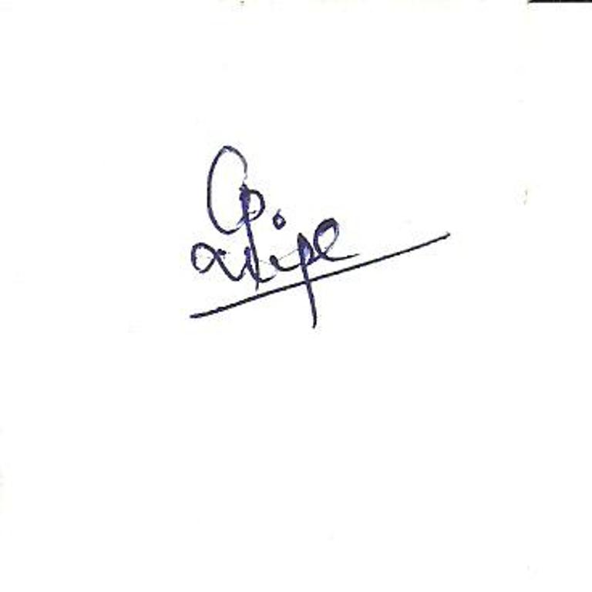

Place : WARDHA (Chandrakant P. Zilpe)

